IN710 OOSD 2017 Practical 4.1 – Strategy Design Pattern
To consolidate your understanding of the Strategy Design pattern, implement the following applications using interfaces and the Strategy architecture. Construct application front-ends that allow you to test your implementations thoroughly, and write unit tests as appropriate. A demo of my solution to each exercise can be found on the I: drive.
As with our previous example tasks, there are multiple ways to implement each of these applications, but using the Strategy Design Pattern will produce architectures that are flexible and extensible.
- Build an encryption tool that uses either string reversal or ROT13 depending on the user’s security setting. The tool must both encrypt and decrypt. The user must be able to change their choice of algorithm at runtime. ROT13 is a simple shift cypher where each letter is shifted 13 places, with wrapping. Thus a->n, b->o, c->p, etc., and r->e, s->f, t->g, etc. Create only one instance of the tool at runtime.
- Build a class which displays the time (continuously, at one second intervals) using either a digital or analogue representation, depending on the user’s selection. Allow the user to show and hide the display, and to change the clock style while the application is running (see the demo). Create only one instance of the class at runtime.
For the digital display, explore the DateTime data type. You can use a Label and a Timer to implement the digital display.
For the analogue display, you can use a 3rd-party control. An example analogue clock control can be found on the I: drive. To insert the control into your Toolbox:
  - Place the .dll in your bin/Debug folder (where the executables live).
  - With your application open in VS, right-click in the toolbox, select Choose Items… and Browse. (There may be a bit of a wait after selecting Choose Items before the Browse button is enabled).
  - Navigate to and select the dll. The AnalogClock control will appear in your Toolbox in the General category.
You can drop an instance of this control onto your Form at design time, just as you do with buttons and list boxes. You can use its Visible property to hide and show it as needed. The clock control runs off the system clock – you don’t need a Timer to make it actually go, just use its Start() and Stop() methods.
If you need help getting started with this application, my IClock interface is shown at the end of the handout.
- You are building a digital catalogue app for an animal shelter. The shelter cares for cats, dogs, rabbit and ducks; the numbers of animals of each species change considerably from week to week. Each week the shelter prepares a text file listing all the animals in the shelter at that time, and they provide a photograph of each animal. Each entry in the text file is a name and a species, as shown:
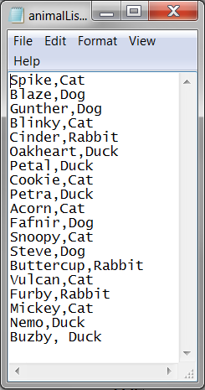
The user selects the species of animal they are interested in. Because of space limitations, the animals’ pictures are displayed only if there are four or fewer of the chosen species in the shelter at the time (as determined by the text file list). When there are more than four animals, the entries are simply listed in a text box. Below are shown three example screenshots:
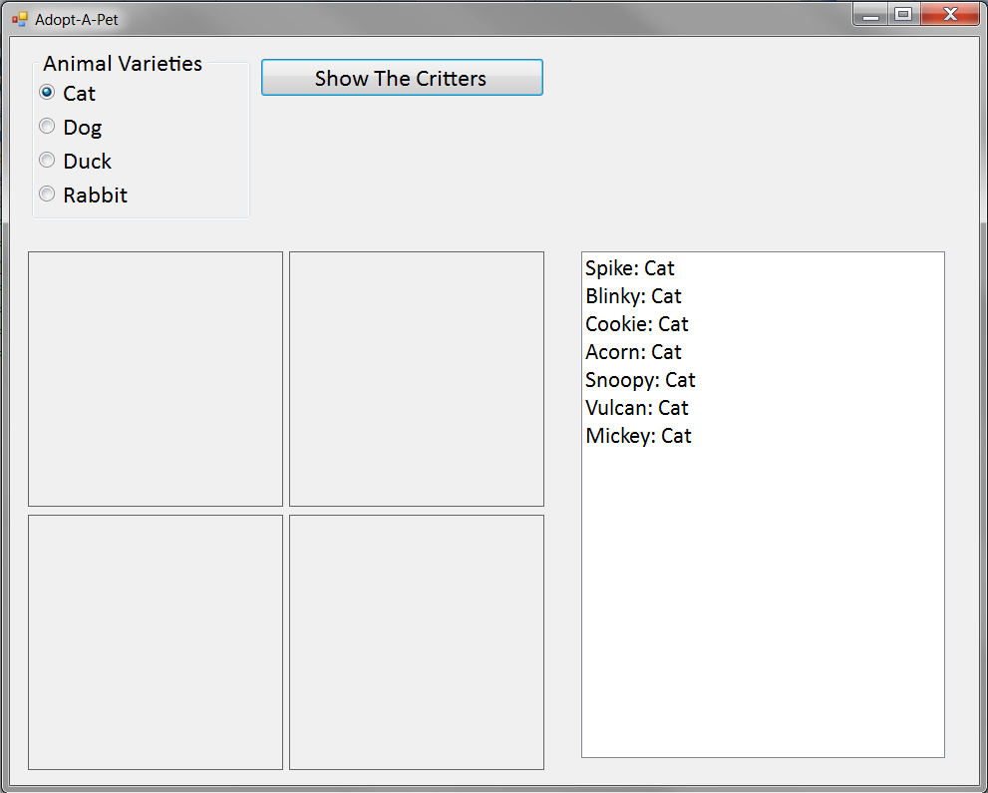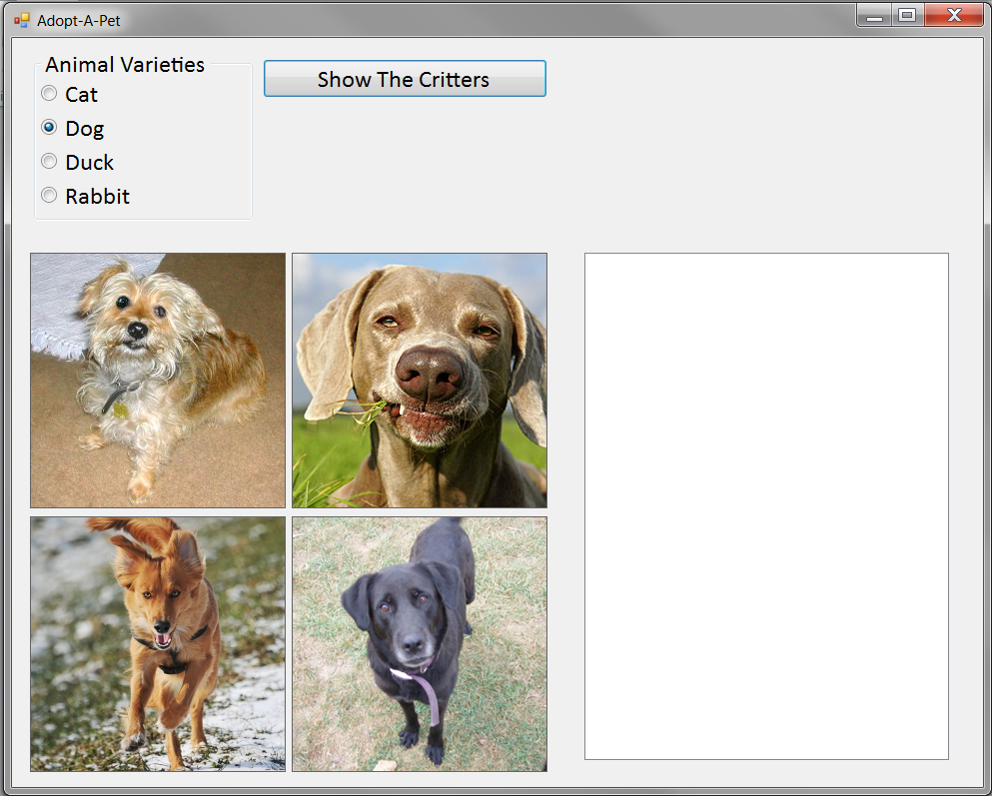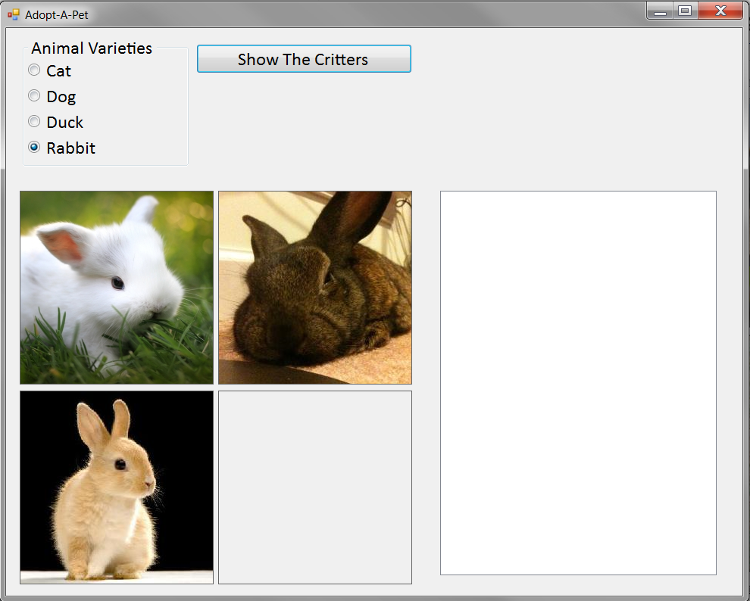

Build this application, using the Strategy Pattern as appropriaate. Make sure that, as the contents of the input text file changes, the displays change correctly (e.g. if you delete three cats from the list, you should see pictures of the cats, without having to change any code). Create only one instance of your digital catalogue class at runtime.
Possibly Useful Code Snippets
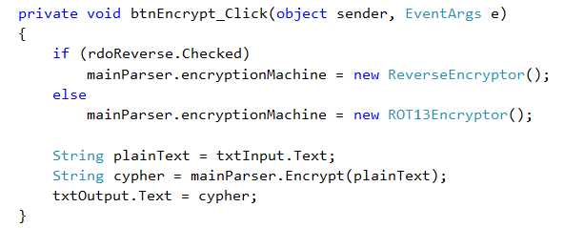
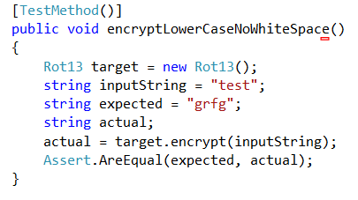
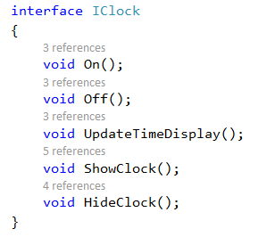
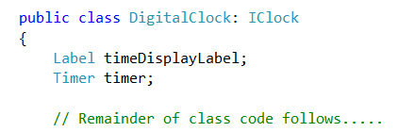

http://www.codeproject.com/KB/selection/AnalogClockControl.aspx

